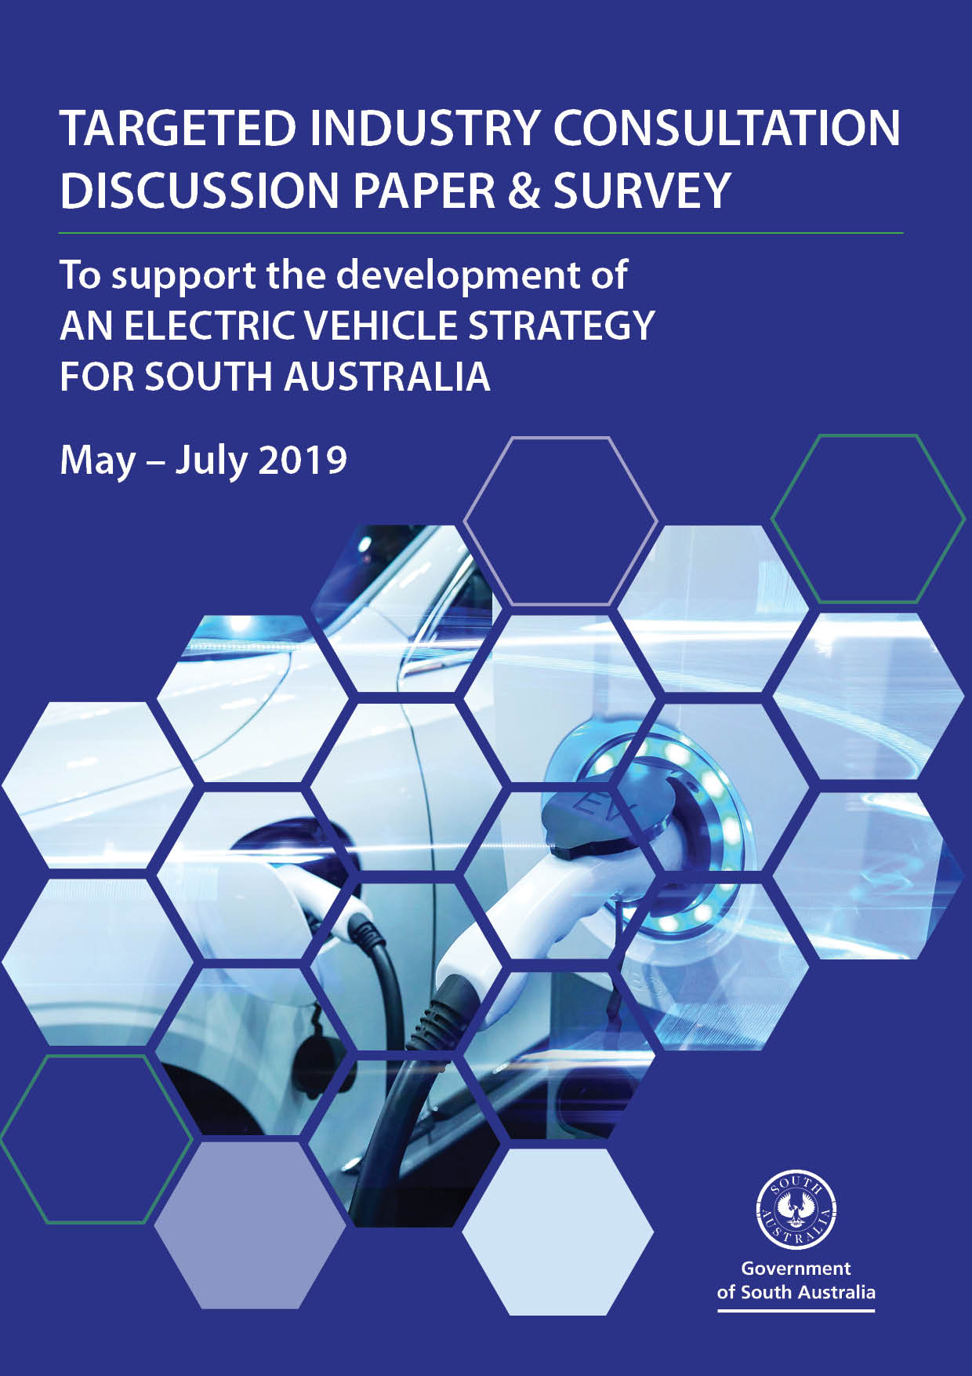

Contents
Purpose 3
What do we mean by electric vehicles? 3
Why are electric vehicles important to the government? 3
The falling cost of electric vehicles 4
The case for a new Electric Vehicle Strategy for South Australia 4
Our Process 5
Contact 5
Timeline 5
Survey 6
Theme 1: Strengthening the local market 7
Theme 2: Raising awareness 8
Theme 3: Charging and refuelling infrastructure 9
Theme 4: Managing impacts to electricity supply 10
Theme 5: Capturing industry development opportunities 11
Theme 6: Supporting policy and regulation 12
Other information 13

Purpose
The South Australian government seeks your views on the challenges and opportunities presented by the rapid emergence of electric vehicles. Your feedback will help shape the development of policies right for South Australia in the ‘near term’ and ‘long term’. In thinking about the emergence of electric vehicles we encourage you to think about the implications for:
- electric vehicle and related supply chains
- the roll-out of charging and hydrogen refuelling infrastructure
- electricity demand, distribution and storage
- public transport including new mobility services
- legislation and government revenue.
We welcome examples of initiatives undertaken by you or others that have the potential to better position South Australia for a future with electric vehicles. While the questions are framed in relation to six key themes, we also welcome additional responses you consider to be important.

What do we mean by electric vehicles?
Vehicles that are capable of being driven in electric only mode for the majority of their use, including:
- Full Battery Electric Vehicles (BEV)
- Plug-in Hybrid Electric Vehicles with an electric only range adequate for daily driving needs (PHEV)
- Hydrogen Fuel Cell Electric Vehicles (FCEV)
- Electric vehicles drawing power from roadside infrastructure.
Unless otherwise specified, use of the term ‘electric vehicles’ throughout this document includes all of the above.
Importantly, these vehicles:
- provide for zero emission transport, reducing or eliminating negative externalities such as toxic emissions, engine noise and greenhouse gas emissions
- require new infrastructure to enable their effective use (vehicle charging or hydrogen refuelling)
- introduce greater complexity to the operation of the power system, which presents challenges and opportunities for improvements
- deliver improved multifactor productivity across their lifecycle when compared to internal combustion engines.
The anticipated scope of policy extends to all registerable electric vehicles including passenger and light commercial vehicles, motorcycles, heavy vehicles and public transport vehicles. Electric bicycles are commended but are not a focus of this policy.

Why are electric vehicles important to the government?
We aim to capture the maximum possible share of economic, social and environmental benefits from the transition to electric vehicles for South Australia. The benefits of electric vehicle uptake include:
- shifting transport energy demand from imported petroleum products to domestically sourced electricity and hydrogen – improving fuel security, resource productivity and national balance of payments
- improved utilisation of South Australia’s abundant renewable energy supplies and contributions to energy storage and grid stability through smart two-way charging
- new opportunities for technology development, manufacturing and skilled jobs in electric vehicle and related value chains
- improved driving experience from a quieter, cleaner, vibration free cabin
- deployment of autonomous technologies, which are more easily implemented in electric vehicles.

The collective economic and environmental benefits from the transition to electric vehicles were recently assessed in a Price waterhouse Cooper (PwC) study titled Recharging the Economy. PwC concluded that a high rate of electric vehicle uptake in Australia to 2030 would:
- increase real Gross Domestic Product by $2.9 billion
- increase net employment by 13,400 jobs
- realise $13.2 billion net investment in charging infrastructure
- eliminate 16 million barrels of imported oil per annum
- reduce cumulative CO2e emissions by 18 Mt
- save consumers $1,700 per year in vehicle ownership costs.
PwC further argued that the rapid transition to electric vehicles presents a low cost option for the transport sector to meet Australia’s emissions reduction commitments under the Paris Agreement.

The falling cost of electric vehicles
Battery electric vehicles are predicted to achieve price parity with equivalent conventional petrol/diesel vehicles in major international markets around 2025. This could eventuate later in Australia if auto manufacturers:
- delay production of new electric vehicle models for minority right-hand drive markets
- continue to preference locations with greater incentives for electric vehicle uptake, particularly if supply is constrained.
Consequently, we anticipate price parity in South Australia sometime between 2025 and 2030 under current conditions. Encouragingly, a number of more affordable and capable electric vehicles have recently entered our local market (priced from $45,000-$60,000 and with a range of up to 450km).
However, the initial higher upfront costs can be offset by significantly lower running costs of battery electric vehicles compared to conventional petrol/diesel vehicles. Energy costs for a battery electric vehicle in Australia are typically about 30 to 45 per cent of those of an equivalent conventional petrol/diesel vehicle and standard servicing costs are typically less than 50 per cent (particularly beyond five years when conventional vehicles require more extensive servicing). Battery electric vehicles will achieve competitiveness on a total cost of ownership basis well before they achieve price parity (assuming similar depreciation rates to conventional vehicles).
Generally, electric heavy vehicles are not as mature in their development as electric passenger cars, however their benefits may prove even greater, particularly for fuel cost savings in the freight and mass public transport spaces. Local industry development opportunities may also emerge in the production of heavy electric vehicles tailored to particular local needs (for example public transport and underground mining vehicles).
Hydrogen fuel cell technology trails battery technology in terms of both cost competitiveness and vehicle availability. However, fuel cell vehicles may have greater long term potential, particularly for heavy freight transport with long distance or heavy duty cycles.

The case for a new Electric Vehicle Strategy for South Australia
The South Australian government seeks to identify a pathway for an orderly transition towards the uptake of electric vehicles that maximises opportunities and minimises risks. The Strategy will articulate and capture the growth opportunities, identify and overcome barriers and minimise any costs to consumers in the transition.

The global transition towards electric vehicles is driven by increasing global demand for low emissions transport, increasing commitments from car makers, government policy, rapidly improving technology and falling costs. Bloomberg NEF forecasts that global sales of electric vehicles will increase from 1.1 million in 2017 to 11 million in 2025 and then 30 million in 2030 as they become cheaper to manufacture than internal combustion engine vehicles.
Policy mechanisms include tightening of national fleet fuel efficiency standards, proposed phase-outs or bans on the sale of internal combustion engine vehicles and policies around clean air and climate change, national industry development and national fuel security. Recent calls from prominent organisations to adopt similar policies in Australia coupled with the falling costs of vehicles and increasing performance of batteries and fuel cells are also key drivers.
South Australia’s power system is in transition, with around 50 per cent of generation coming from renewable sources. As this increases due to the government’s energy programs, this makes South Australia ideal for sector-coupling to reduce emissions from other sources such as transport.

Our Process
The consultation opens on 30/05/2019 and closes 5.00 pm (ACDT) 11/07/2019. Stakeholders are invited to use this document to develop and submit a single response on behalf of their organisation. Stakeholders may also express their interest in a face-to-face meeting.
Responses will inform the development of an Electric Vehicle Strategy for South Australia, which will articulate the South Australian government’s near- and long-term vision, policies and programs for electric vehicles.

Contact
To submit written responses, request a face-to-face meeting and for any general enquiries please contact:
Yvette Booth
Department for Energy and Mining
Ph. (08) 8429 2646 | electricvehicles@sa.gov.au

Timeline

Survey

Instructions
Please complete and return this survey to electricvehicles@sa.gov.au by close of business Thursday 11 July 2019.
Should you wish to provide additional information such as graphics or images, please include as attached documents.
Click on the links below to navigate to the themes and questions

Theme 1: Strengthening the local market
Theme 2: Raising awareness
Theme 3: Charging and refuelling infrastructure
Theme 4: Managing impacts to electricity supply
Theme 5: Capturing industry development opportunities
Theme 6: Supporting policy and regulation
Other information

Before you begin, please include some information about yourself.
Name: | Click here to enter text. |  | Role: | Click here to enter text.
Organisation: |  | Click here to enter text.
Are you submitting this response on behalf of your organisation? Yes ☐ No ☐

Theme 1: Strengthening the local market

The range of electric vehicles in the South Australian marketplace is limited.
The Australian Government has primary influence over the entry of new motor vehicles into Australia through the provision of vehicle standards, import duties and taxation. Compliance costs to establish a new model can be high and need to be offset against futures sales volumes. The South Australian Government levies stamp duty on vehicle sales and annual registration charges.
Recent changes to the federal Motor Vehicles Standards Act 1989 should allow for easier importation of near new second hand electric vehicles from Japan and the United Kingdom under a new Environmental Criteria applicable to the Register of Specialist and Enthusiast Vehicles. New Zealand currently imports second hand electric vehicles and those vehicles sell for well below half the cost of an equivalent new electric vehicle.

Question:
- What should be done to increase the range and affordability of new and used electric vehicles available in South Australia?

Click or tap here to enter text.

Theme 2: Raising awareness

Electric vehicles are an emerging technology and the majority of South Australians have not had direct experience with them. As a result, there are gaps in knowledge of the electric vehicle market and ownership. A recent Australian study found the main barriers to purchasing an electric vehicle were perceptions about high upfront costs and inadequate charging and refuelling infrastructure. This study found that provision of independent information improved consumer confidence in purchasing an electric vehicle.
Questions:
  - What should be done to increase South Australian’s knowledge of and direct exposure to electric vehicle technologies?
Click or tap here to enter text.

  - How can industry and non-government organisations promote and provide opportunities to experience electric vehicles in a non-sales environment?
Click or tap here to enter text.

Theme 3: Charging and refuelling infrastructure

Full utilisation of electric vehicles will be dependent on the provision of a comprehensive network of recharging and refuelling infrastructure across South Australia.
While overseas research shows most electric passenger and light commercial vehicles are slow charged at home overnight or at workplaces during the day, visible public charging infrastructure has proven critical in providing confidence to prospective first time buyers, in particular to ease range anxiety concerns. Dedicated fast charging infrastructure is needed for commercial operations such as buses, taxis and delivery fleets and to enable long distance travel between cities and to regional areas.
For hydrogen fuel cell electric vehicles, the guarantee of long-term hydrogen refuelling stations is critical to uptake to reassure buyers that they won’t be stranded in the future with a vehicle that cannot be used at all.

Questions:
3.1 What level and distribution of public charging infrastructure is required to give private and corporate fleet buyers the confidence to purchase their first battery electric vehicle?
Click or tap here to enter text.
3.2 How can public and fleet recharging and hydrogen refuelling infrastructure be rolled-out (including in regional locations) in an industry-led scalable model?
Click or tap here to enter text.

Theme 4: Managing impacts to electricity supply

Electric vehicles present both risks and opportunities for the management of the state’s electricity supplies. First, as a significant source of additional demand it is important that electric vehicles are mostly charged during periods of peak or excess supply (for instance during the afternoon spike in electricity generated by rooftop solar panels) rather than periods of high demand. This will also help avoid costly upgrades to distribution networks that could arise from unmanaged charging.
As a form of distributed battery storage, electric vehicles have the potential to substantially add to the state’s virtual power plant capacity to cost-effectively shift loads from periods of high electricity supply to periods of high demand. This is of particular importance in South Australia with our high proportion of intermittent wind and solar energy.
The production of renewable hydrogen by electrolysis is also a potential storage medium for excess wind and solar electricity supply. This then provides a local source of hydrogen as a zero emission transport fuel. There is significant potential to expand on the amount of wind and solar generation in South Australia to fuel a future hydrogen economy and to allow for exports to growing Asian markets.

Questions:
4.1 What are the likely impacts of electric vehicles on the grid and how can they be managed?
Click or tap here to enter text.
4.2 Are there specific geographical areas, regions etc in South Australia that might be particularly at risk of projected future charging demand? If so, how can this be managed?
Click or tap here to enter text.
4.3 How can electric vehicles (including hydrogen fuel cell electric vehicles) assist in the transition to smart grids?
Click or tap here to enter text.
4.4 Is there scope for new business models to support electric vehicle uptake in return for benefits provided in energy storage (for example, by utilising 2-way charging within a Virtual Power Plant framework)?
Click or tap here to enter text.

Theme 5: Capturing industry development opportunities

The transition to electric vehicles provides new industry development and employment opportunities across the value chain. This could include for instance local assembly or outright manufacture of new electric vehicles, key components and related infrastructure, research and development opportunities and skills, training and workforce opportunities.
Other closely related areas include developing a local battery value chain, a hydrogen economy including hydrogen production and storage, and using electric vehicles to support new mobility services including autonomous vehicles and shared mobility platforms (such as ridesharing). Niche manufacturing opportunities may arise for electric vehicles for Australian needs, such as mining vehicles.
Other opportunities may emerge from non-transport sectors due to technological synergies and/or joint corporate ownership of complementary technologies. For example a single entity offering cost-effective, low emission packages such as an electric vehicle, solar PV panels, home/business battery storage, smart charging infrastructure, home control systems and innovative financing.

Questions:
5.1 What industry development opportunities do you see arising from the transition to electric vehicles and how can they be captured in South Australia?
Click or tap here to enter text.
5.2 What do you view as South Australia’s key capabilities and strengths in regard to the electric vehicle value chain and how can these be built upon?
Click or tap here to enter text.
5.3 What environmental challenges do you see arising from electric vehicles and how can those challenges be managed cost effectively (for example reuse, refurbishment or recycling of components)?
Click or tap here to enter text.

Theme 6: Supporting policy and regulation

While the transition to electric vehicles will be market led by commercial fleets and individual preferences, it is important that legislation, regulation and government policy supports the uptake of electric vehicles in a safe and cost-effective way.
Regulatory approaches could include:
- planning reforms to standardise development requirements relating to public and private charging and refuelling stations
- planning policy and regulation requiring new buildings to either include electric vehicle charging infrastructure or be electric vehicle ready with provisioning for future charging stations.

Questions:
6.1 What regulatory reform is required in South Australia to remove barriers and/or to create new standards/laws in support of the transition to electric vehicles?
Click or tap here to enter text.
6.2 Are there specific gaps in research and development knowledge that need to be addressed to support the early transition of the electric vehicle industry/sector?
Click or tap here to enter text.
6.3 Is it reasonable to vary government motor vehicles fees and charges according to the CO₂ or environmental impact?
Click or tap here to enter text.
6.4 How can electric vehicles make a fair contribution to road and infrastructure costs if they don’t pay the fuel excise levy?
Click or tap here to enter text.

Other information

7.1 Please include additional information and views that are relevant to the development of an Electric Vehicle Strategy for South Australia that are not captured in the above themes.
Click or tap here to enter text.



Recharging the economy: The economic impact of accelerating electric vehicle adoption (2018). Prepared by Price waterhouse Cooper for the NRMA, Electric Vehicle Council and St Baker Energy Innovation Fund.
For example a medium vehicle travelling 15,000km per year: a BEV consuming 16 kWh per 100km at 38c per kWh will cost $864, a petrol vehicle consuming 9L/100km at $1.40 per litre will cost $1,890 for a saving of $1,026 per year.
Electric Vehicle Outlook (2018). Bloomberg New Energy Finance [accessed 9 April 2019] https://about.bnef.com/electric-vehicle-outlook/
An Analysis of Consumer Incentives in Support of Electric Vehicle Uptake: An Australian Case Study (2019). Gail Helen Broadbent, Graciela Metternicht & Danielle Drozdzewski, World Electric Vehicle Journal, 10, 11
A Virtual Power Plant is a network of home solar photovoltaic and/or battery systems (including electric vehicle batteries) working together to generate and store energy, and feed stored electricity back into the grid when required. In the case of electric vehicles, an owner may be able to charge the battery cheaply during periods of excess supply and return part of this charge to the grid during peak demand period in return for a fee.

